**Diary Management System**

**Advanced Database Design**

**CS-603-B**

##### TechME



Sacred Heart University

School of Computer Science & Engineering The Jack Welch College of Business & Technology

Submitted To Dr. Reza Sadeghi

Spring 2022

CS-603-B Project Progress Report Phase #2 TechME

**TechME**

# Project Phase 02 for

# Diary Management System (DMS)

### Team Members

1. Kiera Cutri cutrik@mail.sacredheart.edu
2. Ankush Chaudhari chaudharia@mail.sacredheart.edu

### Roles of Team Members

1. Kiera Cutri (Team Head)
2. Ankush Chaudhari (Team Member)

2

CS-603-B Project Progress Report Phase #2 TechME

## Table of Contents

Table of Contents 3

Team Member Introduction 4

Project Summary 5

Purpose

Scope

Motivation

ER Model 6

EER Model 7

Entities and Keys 8,9

Citations 10

3

**Team Member Introduction**

**Kiera Mariah Cutri**

SHU ID Number: 0813395

SHU Email: [cutrik@mail.sacredheart.edu](mailto:cutrik@mail.sacredheart.edu)

Kiera Cutri is a current Computer Science graduate student at Sacred Heart University; they have previous experience with C++, C#, Java, and Python. Kiera has previously worked at the Sacred Heart Factory as a level one technician for 3 years where she gained experience with troubleshooting various software issues; she has also performed various repairs and upgrades to her laptop.

I met Ankush after the first Advanced Database course and we conversed about interests, backgrounds, and hobbies. After finding common ground for interests, I thought that he would be a good partner for the project, he reached out to me first regarding group work. The team leader was decided through a discussion of responsibilities and through deciding who would prefer to take the role.

**Ankush Chaudhari**

SHU ID Number: 0882634

SHU Email: [chaudharia@mail.sacredheart.edu](mailto:chaudharia@mail.sacredheart.edu)

I am Ankush Chaudhari. Presently, I am a graduate student at Sacred Heart University. I have completed my Undergrad in Electronics and telecommunication engineering; after, I used to work for an MNC as an implementation consultant for 1.6 years. Basically, my role was to handle ERP systems, Client relations Project Management, Vendor Management, provide clients hands on training on the system, and design and integrate the system according to client requirements. I am very passionate about my work role. my team has received an extra mile reward for completing the project before the deadline.

It was the first day of my Database Management class. I was seated in the first row. Kiera was seated towards my right. We had little conversation regarding the software installation and some doubts. After class we had a brief conversation regarding our backgrounds. Kiera completed her undergraduate in gaming, she also told me about her interest in various programming languages which she has known. On that point I decided that Kiera is a perfect team partner and head, so I approached her and now we are a team.

4

**Purpose**

The purpose of the Diary Management System (DMS) is to aid staff members within a department to collaborate and organize in a school setting. This system allows faculty members to update their activity details within a diary that is accessible to relevant users. Permitted users will have access to the activity of specific events that have been logged within the system. This proposed system aims to minimize the time burden imposed on faculty members by allowing users to search for a colleague's log within their diary. The Head of Department (HOD) will be able to view each faculty member's diary logs.

**Scope**

TechME aims to produce an application that will provide greater ease for users by allowing users to effortlessly search and find records that pertain to other colleagues. This system provides users with an advanced and secure way to store documents than can be accessed by higher ups within a department.

**Motivation**

These days, everything is stored within databases. Our staff continues to use more traditional logging methods when recording work information. To make the most out of current technology, we are creating a work diary management system which will allow faculty members to upgrade their work from traditional logging techniques to databases.

**Literature Survey**

Keeping logs to maintain work records daily allows faculty members to keep track of their work in their department. Each faculty member keeps and maintains a traditional diary which stores logs of their workday. Faculty members input various information relevant to their workday such as attendance, course number, semester taught, comments for the class, and content covered during lecture. The diary logs are later reviewed by the Department Head at the end of the day. Within our college, every faculty member keeps and maintains a work diary to enter logs of their workday daily. By maintaining a work diary, it allows faculty members to detail their workday and keep a log that would be available to other coworkers within their department. By having a diary system in place, it allows others to know the daily routines of faculty members and allows for easier assignment based on availability.

We were able to gauge an idea of how this system would work based on an online example of a diary management system on sourcecodester.com [2].

**Pros and Cons**

When considering the Diary Management System. We considered potential positives and negatives that would attribute to the system. The primary positives of the system would be that it would provide an accurate timeline of events and permit for easier scheduling of employees. The system would be able to support multiple team members at once and would allow coworkers to hold each other accountable for each other for specific actions preformed. The primary potential negatives we came across for this project would be a decrease in teamwork among members, large data size which use large pieces of software which would occupy multiple megabytes of diskspace, there could be an annual recurrent maintenance cost, and an ethical concern for privacy.

For more information regarding this project, please refer to the following github repository: <https://github.com/cutrik/CS603-FinalProject>

5

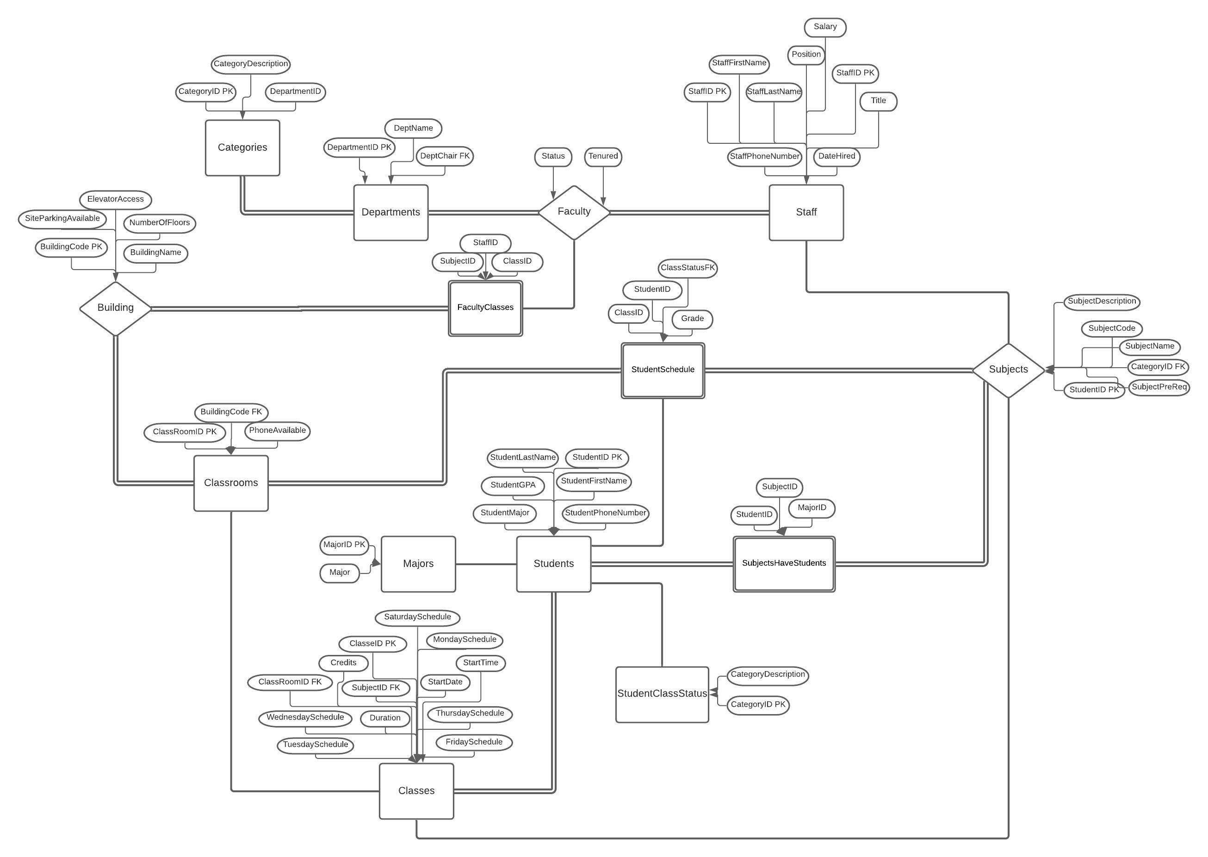**ER Model**

Created in Lucidchart at [www.lucidchart.com](http://www.lucidchart.com) [3]

6

**EER Model**

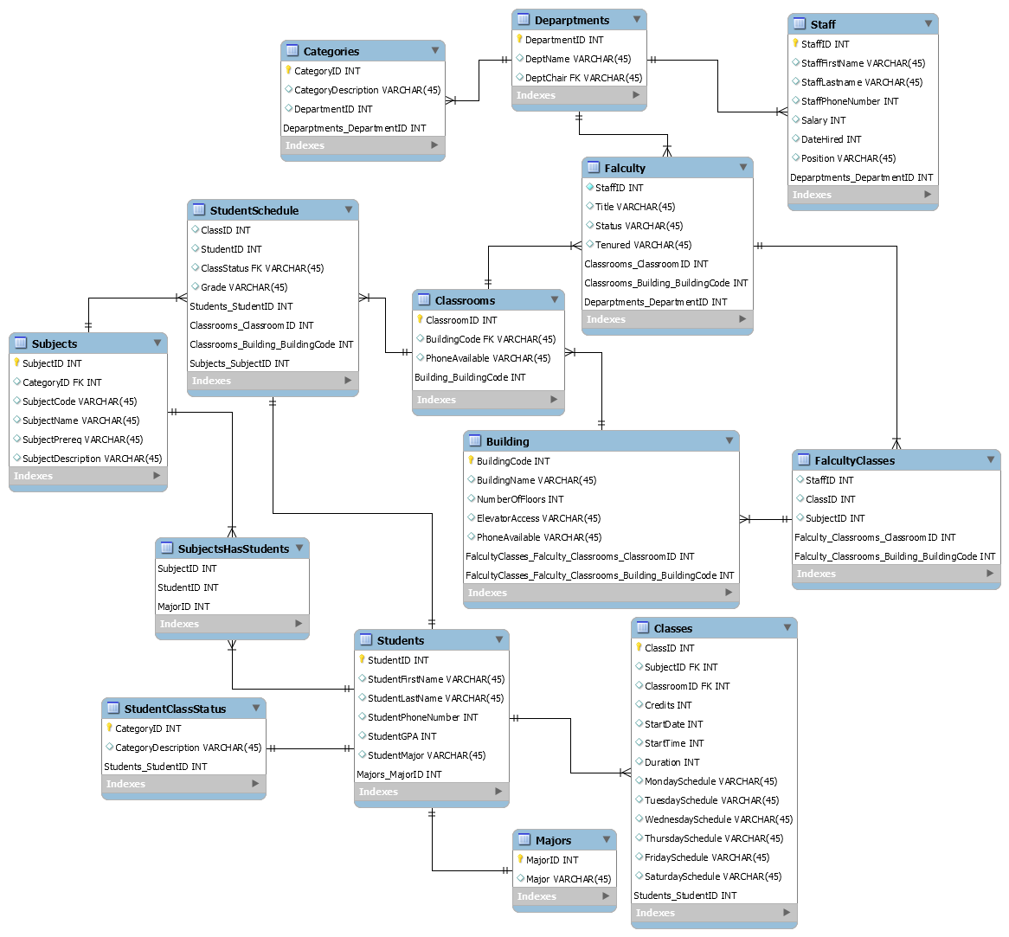

[1]

7

**Entities and Keys**

When selecting entities for our project, we examined how a university or college works and attempted to mimic how they operate within the database. We began by looking at the direct relationships among members of an institution; we noticed that there were individuals who worked for the institution which fell under faculty or staff members. We noticed that students interacted with both faculty and staff. Since faculty and staff members played a vital role in the Diary management System, we included them in our entity list.

We observed that the institution utilized multiple buildings and classrooms which members of the institution interacted with. When we looked to how faculty members use the building, we included aspects which were being used. Building name, classroom location, department, and the subject which the faculty member taught were all aspects of the institution which would allow for more detailed diary entries. Faculty members have information that pertain to themselves and to other aspects of the institution such as scheduling and teaching. Faculty members belong to different departments based on their specialized subjects which impacted what they would teach to students.

We noticed that the faculty members schedules aligned with what students would take based on what the faculty member would teach; we thought it important to include aspects of the student and faculty interaction in our database using student class status and student schedule. We noticed that students typically had declared one major but would still take a variety of subjects for their schedule. With each subject that a student would take, each class would occur at different times and different days for varied durations.

**Faculty**

StaffID PK

Title

Status

Tenured

**Staff**

StaffID PK

StaffFirstName

StaffLastName

StaffPhoneNumber

Salary

DateHired

Position

**Departments**

DepartmentID PK

DeptName

DeptChair FK

**FacultyClasses**

StaffID CPK

ClassID CPK

SubjectID CPK

**Subjects**

SubjectID PK

CategoryID FK

SubjectCode

SubjectName

SubjectPreReq

SubjectDescription

**Categories**

CategoryID PK

CategoryDescription 8

DepartmentID

**Classes**

ClassID PK

SubjectID FK

ClassRoomID FK

Credits

StartDate

StartTime

Duration

MondaySchedule

TuesdaySchedule

WednesdaySchedule

ThursdaySchedule

FridaySchedule

SaturdaySchedule

**Classrooms**

ClassRoomID PK

BuildingCode FK

PhoneAvailable

**Building**

BuildingCode PK

BuildingName

NumberOfFloors

ElevatorAccess

SiteParkingAvailable

**StudentSchedule**

ClassID CPK

StudentID CPK

ClassStatus FK

Grade

**Students**

StudentID PK

StudentFirstName

StudentLastName

StudentPhoneNumber

StudentGPA

StudentMajor

**SubjectsHaveStudents**

SubjectID

StudentID

MajorID

**StudentClassStatus**

CategoryID PK

CategoryDescription

**Majors**

MajorID PK

Major

9

**Citations**

1. Viescas, John L. “School Scheduling Modify Database Page 883.” *SQL Queries for Mere Mortals: A Hands-on Guide to Data Manipulation in SQL*, Pearson Technology Group Canada, 2018.
2. elinet. “Elinet.” *Free Source Code, Projects & Tutorials*, 11 Sept. 2014, https://www.sourcecodester.com/php/7943/online-diary-management-system.html.
3. W, Megan. “Urgent! -- Cite LudicChart – Lucidchart.” *Lucidchart*, 20 Sept. 2018, https://lucidchart.zendesk.com/hc/en-us/community/posts/360018227346-URGENT-Cite-LudicChart.

10